Modelling and Simulation of an EDM Die Sinking Machine
M. Kocher and P. Guglielmetti
Charmilles-Technologies, Geneva, SWITZERLAND
1. Abstract
As analysed by a Control engineer, an EDM machine is composed of many overlapped hardware and software Control loops. Each loop contains a regulator and a linear or non-linear system like the motor, the mechanics and the EDM process. One problem is that each loop controller is often designed individually and nothing is done in order to harmonise the dynamic behaviour of the whole scheme.
The goal of this paper is to present a methodology allowing the analysis of an entire EDM Control loop in the context of Die Sinking.
2. Introduction
In [1], the idea of a non linear controller used to monitor the gap width has been described as illustrated in Figure 1. This idea has been used in this paper in conjunction with the use of a powerful simulation tool. To use this tool, the complete block diagram of the erosion process viewed under a Control angle is established and each of the components are described. This difficult exercise is very useful because it demonstrates the role that each bloc plays in the global dynamic response and because it allows the global optimisation of the process to be performed.
Fig. 1 Non-linear controller response describing the electrode speed as a function of the ratio (measured ignition delay / reference ignition delay). After [1].
3. Description of the Control loop
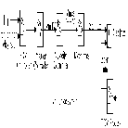
Fig.2. Complete block diagram of the controlled erosion process.
The goal of the Control loop described in Figure 2 is to monitor the gap width between the electrode and the part to be machined to a preset value in the case of a single axe displacement, in this paper, the Z axis. Unfortunately, the gap width can not be measured and an indirect value, the average ignition delay, is used to get an estimate of the gap width as will be described in section 6.
The error between the measured average ignition delay rate and the reference ignition delay rate is used as the input of the EDM Controller which output is fed to the position Controller. This EDM controller will be described in section 7.
The position controller combines this velocity information in the gap direction with the trajectory information to create, in case of a multi-axe movement, the velocity reference for each axe.
The analogue velocity controller, used to monitor the motor velocity is described in details in section 4.
After this loop, the motor velocity is the input of the mechanical block that describes the dynamic behaviour of the machine and outputs the final electrode position as described in section 5.
This electrode position is the input of the state space engine described in section 6 which goal is to estimate the average ignition delay as a function of the electrode position, and the EDM parameters that set the matter removal rate in [mm3/min]. The on-time, the off-time, the current intensity, and the electrode surface belong among others to that set of parameters.
4. Description of the velocity loop
This subsystem, which goal is to monitor the motor velocity is made of two nested loops : the current loop and the velocity loop. The motor is a classical DC motor driven in intensity and the whole block diagram is described in Figure 3. In this figure where the current loop was omitted because of its very short time constant, the following blocs can be seen.
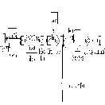
Fig. 3 Block diagram of the velocity controller part of Fig. 1.
First, a low pass RC filter is used to smooth the incoming reference velocity. After filtering, this signal is subtracted from the measured velocity, which is obtained through a tachometer directly linked to the motor, to give the velocity error. This signal is then multiplied by a gain, the proportional gain of the Control loop, low-pass filtered, and converted to the motor intensity reference. This current which is limited both in slope by the motor inductance and voltage to about +/- 8 [A/ms] and in current to +/- 9 [A] is then transformed in the torque reference by a simple factor.
At this point, two new features are included in the model. They describe the influence of the gravity and of the dry friction on the system's dynamics. Because the described EDM process works along the vertical Z axis, the torque reference has first to be decreased by a quantity proportional to the weight of the Z axis as seen by the motor. This is due to the definition that a positive torque initiates a displacement in the up direction. The second influence is due to the dry friction of the Z axis modelled here by a Coulombs moment depending on the sign of the velocity. The following experimental set-up has allowed to determine the relative influence of these two components. Let I+ and I- be the minimal intensity allowing the movement of the Z axis respectively in the up and down direction. Let M+ and M- be the corresponding torques as given by the motor constructor. The M+ torque has to overcome the sum of the weight torque P and the friction torque F whereas the M- torque is equal to the difference of these torques resulting in equation 1. From this equation, it was possible to get the numerical value for both the weight torque P and the friction torque F.
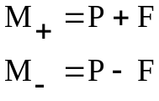 (1)
The net torque then results form the subtraction of the reference torque from the friction torque and from the weight torque. This value is used to drive the mechanical system as seen by the motor. This system can be modelled by an inertia J and by a viscous damping f. The inertia J as seen by the motor is calculated analytically by taking into account all the inertia in the mechanical system. The viscous damping f is estimated by analysing the ratio between the imposed net torque and the stabilised measured velocity.
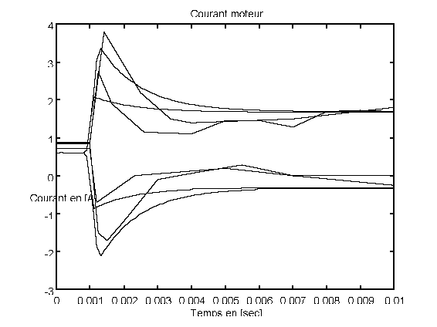 | 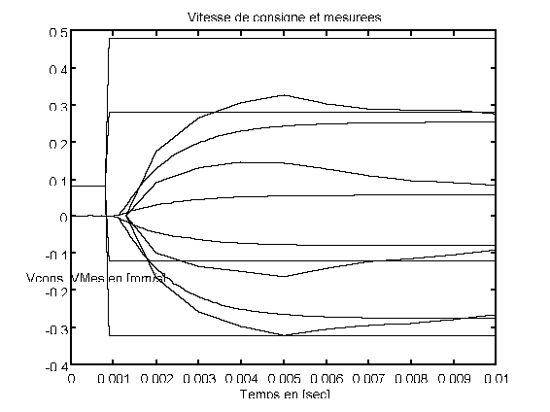
Fig. 4 Simulation of the velocity controller when the reference speed follows a step unit from 0 to (-0.3, -0.1, +0.3 and +0.5 [mm/s]).
4a) : Evolution of the intensity through the motor as a function of time.
4b) : Evolution of the actual velocity as a function of time.
The complete system described in Figure 3 has been simulated by using a step function at the reference velocity input and by looking at the motor intensity and at the measured velocity. This simulation is illustrated in Figure 4a and 4b for a step reference velocity of -0.3, -0.1, +0.3 and +0.5 [mm/s]. From these figures, the following conclusions can be drawn. First the offset effect of the gravity is clearly seen by looking at the static error of the velocity for both the positive and negative velocity references. Second, the non-linear behaviour of the system appears when looking at the common speed rising slope in Figure 4. Third, the dynamic response of the system is degraded for commands lower than 0.5 [mm/s]. This last point is very critical because in die sinking EDM, the sign of the reference velocity changes very often and the magnitude of the command is low, which means that the stable point of the system is extremely affected by the non-linearity due to the dry friction.
5. Identification of the mechanical bloc diagram
The identification of this supposedly linear bloc is performed by measuring the transfer function between the motor velocity given by the tachometer in [mm/s] and the absolute position of the electrode in [um]. The experimental Bode diagram indicates the presence of an integrator and of a small resonance peak at 130 [Hz] very well damped (the peak overshoot is estimated at +3 [dB]). The following equation summarises this observation by giving the transfer function between the motor velocity and the electrode position.
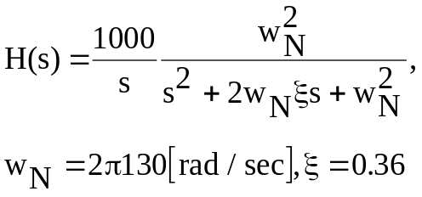 (2)
6. Identification of the EDM process bloc
This bloc is used in the global scheme shown in Figure 2 to transform the electrode position into the average ignition delay.
Figure 5 and 6 present experimental results proving that the gap is related to the averaged ignition delay with a non-linear relation as long as the number of discharges used to average the ignition delay is high enough. Based on this result, the following algorithms are activated. First, the part position is simulated by taking into account the matter removal rate in [mm3/s], the electrode surface in [cm2] and the gap in [um]. Second, the gap is formed by subtracting the electrode position from the part position. Finally, the gap is used to create the ignition delay by using the experimental curve in Figure 5. An uncorrelated random variable is added to this delay for each discharge to take into account the stochastic nature of the process.
Fig. 5. Relation of the average ignition delay in [usec] and the gap in [um] for different fluid velocities. After [1].
Fig. 6. Influence of the number of sparks used to get the averaged ignition delay on the correlation between the gap in [um] and the averaged ignition delay in [usec]. After [2].
7. Description of the EDM Controller
In this bloc, the output of the EDM Process bloc, the per discharge ignition delay is low-passed filtered to give an estimate of the averaged ignition delay. This value is then subtracted from the reference ignition delay and multiplied by a gain to give the controller error, resulting in a proportional controller.
8. Description of the position regulator
The purpose of this controller is first to monitor the gap width to a preset value and second to ensure that the 4D trajectory of the electrode (X, Y, Z, C) is followed as close as possible. The trajectory following aspect of this regulator will not be described in this paper.
The gap width controller is made of an A/D converter, a simple proportional gain and a D/A converter. This bloc, that can obviously be transformed into an analogue gain, has been kept as is to study the effect of the sampling period of the converters on the global system dynamic performances. An empirical rule [3] is to set the sampling frequency to twenty times the value of the closed loop bandwidth of the system to be controlled. This system as presented in Figure 2, without the position controller and linearized around a working point has a -3 [dB] bandwidth of about 60 [Hz]. By using the empirical rule described above, it comes out that the sampling period should be smaller or equal to about 1 [ms].
9. Simulation of the entire loop
In the preceding sections, the velocity controller, the mechanics bloc , the erosion bloc, the EDM controller and the position controller have been individually described. The model of these blocs has been simulated and validated experimentally.
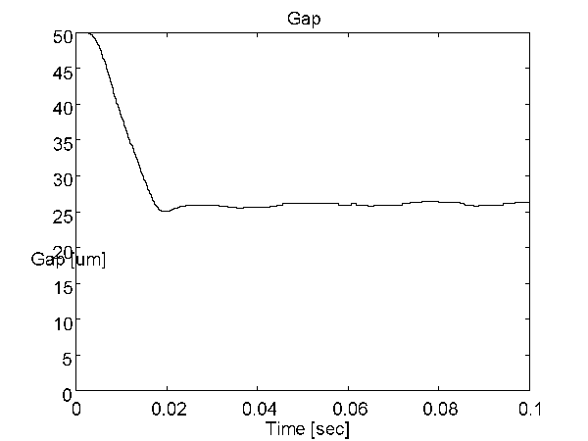 | 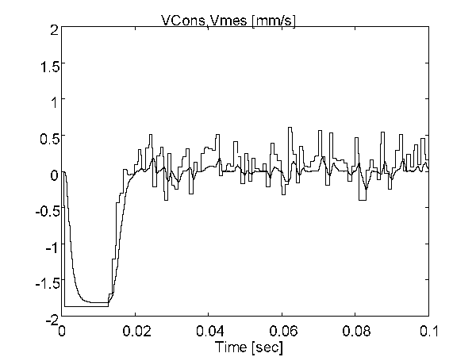
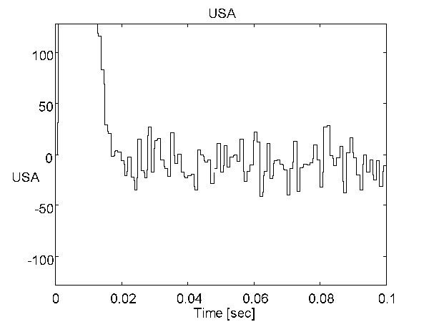 | Fig. 7. Simulation results describing  the temporal evolution of the gap,  the control error and the reference and measured electrode velocities.
Figure 7 presents the results obtained by simulating the global scheme described in Figure 2 with the following conditions. At time t=0, the electrode is at a distance of 50 [um] above the part. The reference gap is set to 27 [um] which corresponds to a reference ignition time of 14 [us]. The proportional gains of the EDM and position controllers are respectively set to 5 and 60 and the sampling period of the position controller is set to 1 [ms]. Figure 7 shows that the gap decreases from 50 to 27 [um] in about 20 [ms] and remains at this stable value. The output of the EDM controller bloc, USA which is the difference between the reference and the measured ignition delay amplified by the EDM gain, is maximum at t=0 and goes down to about 0. The noise level is a measure of the stochastic nature of the ignition delay. The reference and measured velocity signals indicate that the electrode velocity goes down in about 20 [ms] from -1.7 [mm/s] in the descending phase to about 0 [mm/s] in the erosion phase. This result show that the parameters used lead to a stable, fast and robust to noise Control scheme. The advantage of this simulation is to allow the adjustment of all the individual parameters in the goal of optimising the overall performance.
10. Summary
The analysis of the complete EDM process in Die Sinking viewed under a Control angle has permitted to build the block diagram shown in Figure 2. Each bloc was analysed and described in terms of linear and non-linear equations. Thank to the use of a powerful simulation tool, each bloc was simulated and this simulation was validated experimentally. Finally, the entire Control loop was simulated and the critical parameters like the EDM Controller gain, the position Controller gain and sampling period were set in accordance to a global stability criteria.
11. Bibliography
[1] Dirk Dauw, "On Line Identification and Optimisation of Electro Discharge Machining", University of Louvains, PhD Thesis, 1985.
[2] Bericht 225-4/90, Prozessanalyse beim Senken und Folgerung für die Spaltweiterreglung und deren Optimierung, WZL Laboratorium für Werkzeugenmaschinen und Betriebslehre, University of Aachen.
[3] Gene F. Franklin, J. David Powell, Michael L. Workman, Digital Control of Dynamic Systems, Addison Wesley, 1992.

